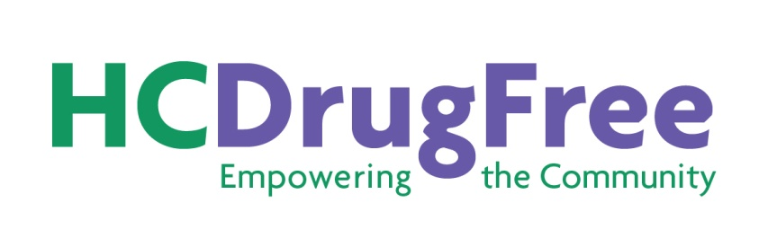
Please attach a photo of yourself (can be a ‘selfie’) to help advisors learn names faster. Thanks!
Teen Advisory Council (TAC) Registration Form (2020 – 2021)
Student Name: _________________________________________________________ Age: ______
Student Email: _____________________________________________
Student Cell Phone: _________________________
Street Address: ____________________________________________________________________
City: _______________________________________________ Zip Code: ____________________
School: ___________________________________ Grade: _______ Date of Birth: _____________
Hispanic/Latino: Yes / No Gender: Male / Female / Other ____________________
Circle all that apply: Asian African-American Caucasian Indian/Alaskan Hawaiian/Pacific Islander
Explain briefly why you are interested in joining the TAC: ____________________________________________________________________________________________________________________________________________________________________
Please list any activities you’ve been involved in (school, sports, community, work). Feel free to use the back of this form or another piece of paper:
____________________________________________________________________________________________________________________________________________________________________
It is expected that members of the HC DrugFree TAC will do their best to:
* Attend five of the monthly TAC meetings
* Participate in discussions at meetings and by e-mail
* Attend two HC DrugFree programs each school year (includes the 2 medication Take Back collections or other programs)
__________________________________________________________________________________
Parent/Guardian Information:
Telephone Home: ____________________________ Cell: _________________________________
Parent/Guardian E-mail: ____________________________________________________________
Authorization and Release: I grant permission to HC DrugFree and other media agencies to use any photograph and video/audio recording taken of my minor child during activities related to HC DrugFree’s TAC, and to use, reproduce, edit, store, distribute, display, transmit, and create derivative works. I hereby waive any rights to inspect or approve the finished photographs, printed materials, video or audio recordings that may be used in connection with them including displaying my child’s name. I hereby agree to release, defend and hold harmless HC DrugFree, other media sources and their employees, officers and agents from and against any claims, damages or liability arising from or related to the use of the photographs and video/audio recordings described in this authorization and release. Also, I hereby agree to release HC DrugFree from and against any claims, damages or liability arising from or related to participation on TAC. I am the parent/legal guardian of the minor named above and I on behalf of my child and myself agree to be bound by all the terms and conditions of this release.

Parent/Guardian Name: ______________________________________________________________

Parent/Guardian Signature Required: _________________________________________________
Please complete and return this form to Admin@hcdrugfree.org or mail to HC DrugFree,
5305 Village Center Drive, Suite 206, Wilde Lake Village Center, Columbia, MD 21044.
For more information, go to www.hcdrugfree.org or call HC DrugFree’s Executive Director Joan Webb Scornaienchi at 443-325-0040. Don’t forget to include a photo to help us learn your name.
Updated 6-22-2020

